Name : Zaryab

Roll Num : BSCS/S17/0109

CMS ID : 293-2017

Artificial Intelligence Lab 1

Lab Tasks

1- Write a prolog code for following Scenario. Compile and run it. Also attach results which shows following :

* All facts you have declared.
* Check the facts

Facts

Schedule of classes -- &gt; Per day one course

Difficulty level of course --- &gt; hard, medium, easy

Also write that how many facts, rules, predicates and clauses are present in your code.

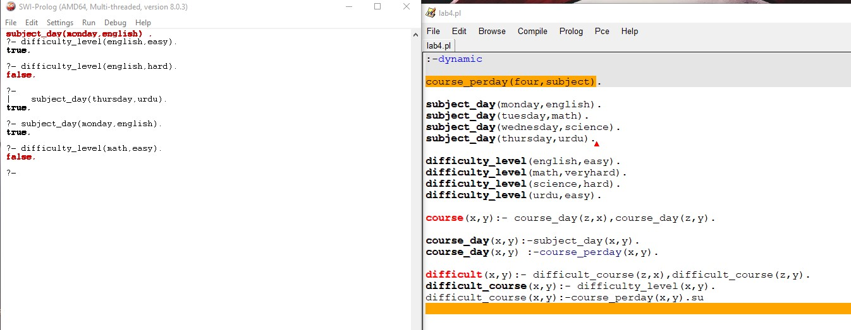

There are 8 facts, 14 clauses , 6 rules and 4 predicates.

2- Write a program for Scenario: Arham , Ali , Sobia are three siblings . They have different habits

under stress. Sobia eat burgers under stress, Ali go on outing under stress, Arham watch TV under stress.

Write:

All facts you have declared

All rules checked by applying different values in variable.

